Westfield Church Parish Child Protection Policy Statement
Parish of St John the Baptist Westfield

The following policy was agreed by the PCC of Westfield Church

at the meeting held on 10th October 2022

As members of this PCC we are committed to the safeguarding, care and nurture of all our members, particularly the children and young people.

We recognise that our work with children and young people is the responsibility of the whole church community and, consequently, safeguarding is the responsibility of everyone.

We are committed to implementing the House of Bishops’ Child Protection Policy ‘Protecting All God’s Children, 2010, and the diocesan procedures, which are based on the Children Act, and Government guidance “Working together to Safeguard Children”, both published in 2013.

We will display in church the Workers Parish Guide, there will be copies available to take away. This contains useful information and advice for those working with children.

We will carefully select and train ordained and lay ministers; volunteers and paid workers with children and young people. We will use the Disclosure and Barring Service, amongst other tools, to check the background of each person who is eligible.

We will respond, without delay, to every concern made that a child or young person, for whom we are responsible, may have been harmed.

We will co-operate fully with statutory agencies during any investigation concerning a member of the church community.

We will seek to ensure that any child, young person or adult who has suffered abuse is offered support that meets their needs.

We will care for and supervise any member of our church community known to have offended against a child.

We will review this policy annually and as part of this process will ensure that all our procedures, particularly in relation to the Disclosure and Barring Service, are up to date.

Our Church Safeguarding Representative is:
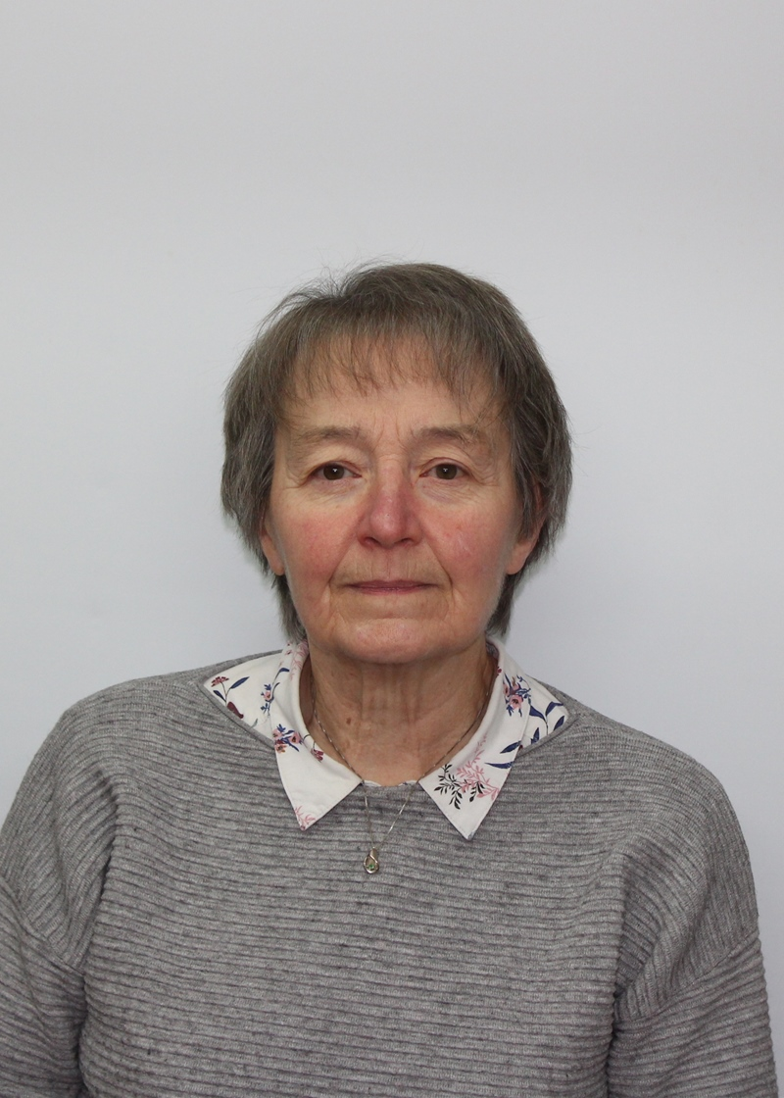

Photo of Safeguarding Officer

Name Cathy Williamson

Address Cockmartins Farm, Westfield Lane, Westfield, TN35 4SB

Telephone number Home: 01424 754922 Mobile: 07765258012

Email address: cathymwilliamson@btinternet.com

Our CCPAS Lead Recruiter is: Cathy Williamson

Name/Signed………Sandi Wickens…………Incumbent

Name/Signed………Dawn Archer……………Churchwarden Date 10th October 2022

Name/Signed………Kathy Darvill……………Churchwarden

A copy of this statement is to be displayed in the church and a copy sent to the Bishop’s Advisor for Safeguarding

