Westfield Church Notices Sunday 13th April

Valerie writes:

Holy Week

All glory, laud and honour,
To Thee, redeemer, King.
To whom the lips of children
Made sweet Hosannas ring.
Thou art the King of Israel.
Thou David's royal son,
Who in the Lord's name comest,
The King and blessed one.

This week we remember how the crowds shouted 'Hosanna in the Highest' as Jesus rode into Jerusalem on a donkey. The praise of Palm Sunday soon changed as the crowd called for Jesus' crucifixion.

Issac Watts draws us to experience the scene by the cross in his poignant hymn:

When I survey the wondrous cross
On which the Prince of Glory died.
My richest gain I count but loss
And pour contempt on all my pride.

He allows and invites us, the singers, to bring our own faith to the foot of the cross.

See from His head, His hands, His feet,
Sorrow and love flow mingled down,
Did e'er such love and sorrow meet,
Or thorns compose so rich a crown.

In the last verse we turn our personal commitments to God and bring our hopes and aspirations. We can't be passive worshippers as we sing:

Were the whole realm of nature mine
That were an offering far too small,
Love so amazing, so divine
Demands my soul, my life my all.

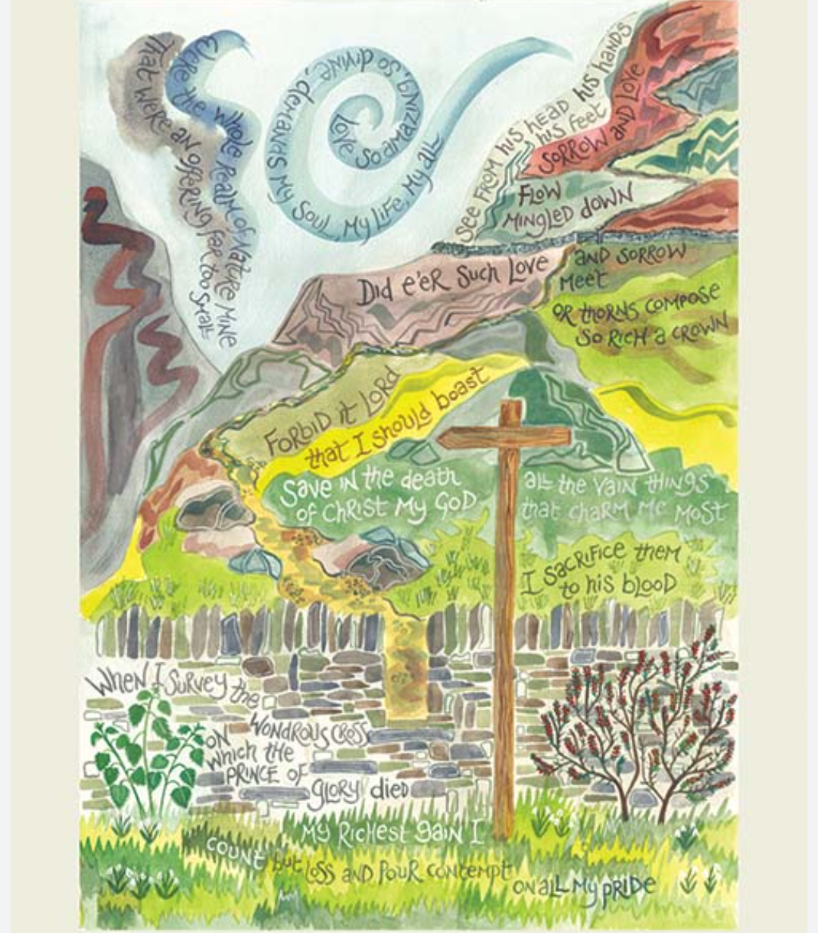

Easter at Westfield Church:
Thursday April 17th
Maundy Thursday Service 7pm
Friday April 18th
Good Friday Service 3pm
Sunday April 20th
Easter Sunday Holy Communion 8am and 9.30am
Sunrise Celebration 5.45am

Messages:

Church Electoral Roll
Pease could forms for enrolment onto the Church Electoral Roll and the accompanying GDPR form be returned to Marian Newman – Electoral Roll Officer by 20th April at the latest in person or via email: Subject Heading “Westfield ER” to paforfgw@gmail.com or placed in the black post box in the Church porch.
Home Groups
Both groups restart after Easter on 30th April. We start at 7:30 pm.
All are welcome.

Toddler Group

Usually at this time of the year we are looking forward to opening up the toddler group again but for this to happen we’re needing a little help please. There are occasions when Ann and Sandi can’t be around on Wednesday afternoons, 1pm - 3pm, so we would like to add two more people to the team to ensure we don’t have to cancel at the last minute. If you are someone who enjoys meeting families, encouraging them and engaging with pre-school children please have a pray and a think about joining this small and happy team. Safeguarding training will be provided. Please speak to Ann G or Sandi to find out more.

God bless,
Sandi

APCM meeting dates

4th May Westfield
11th May Guestling
18th May Fairlight

What’s On:
Sunday April 13th
8.00am: Prayer Book Communion
9.30am: Palm Sunday Service
Tuesday April 15th
7.30pm: Prayer Group at Brenda’s House Greenacres
Wednesday April 16th
Please note their will be no Holy Communion at 8.30am – Sandi will be in Chichester at the Chrism Service where the priests serving in the Diocese renew their priestly vows and the oils used for Baptisms, Ordinations and Healing are blessed.
10.30am Warm Space Community Hub
Wednesday April 30th
Care For What You Believe 6.30pm
Join Celia and Lyndon Bowring as they host a Pray for the Nation Evening
The Spa Hotel, Royal Tunbridge Wells, TN4 8XJ
Care.org.uk/events or 020 7233 0455 for further details
Sunday 4th May & Monday 5th May
Westfield Community Association, in association with the Parish Council, will be hosting a free exhibition of Westfield memories and recollections of everyday life to mark the end of WW2 and the 80th Anniversary of VE Day. This will be in Westfield Community Hall from 10.30am on Sunday 4th and Monday 5th May. See the back page of your February-May Westfield Community Newsletter (spare copies in The New Inn or Strawberry Fair) for more information.
Janice
Wednesday May 14th

Rye Deanery trip to Chichester Cathedral

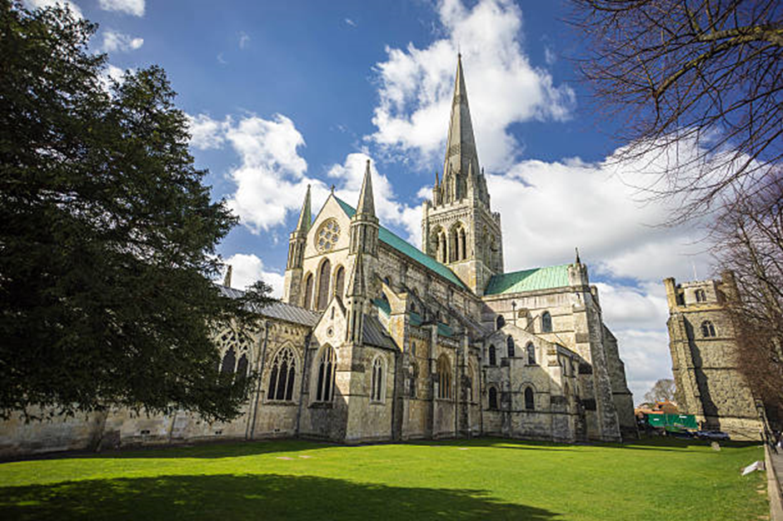

Come and join us on a day-trip journey to Chichester Cathedral – our Mother Ship, in this the 950th year of our Diocese.

We will be leaving in the morning and can arrange to have a Eucharist especially for us at lunchtime, followed by a meal, if you would like to. Tours of the Cathedral can be arranged if you would like to do this.

If you are interested, please let Rev. Kate Bailey know as soon as possible. If enough people would like to join us, then we will look into the cost and availability of coach hire, as well as the lunch and tour costs of the Cathedral.

We hope that as we travel as a Deanery, we will find ourselves joined closer together in our faith, as we visit the heartbeat of our Diocese.

Rev. Kate Bailey
01797 253118 rector@stmaryschurchnorthiam.co.uk

Prayer:

If you would like a situation prayed about urgently, please contact the church Prayer Share. Contact Dawn 01424 255423 / 0750 7745 159

If you know anyone who would like to be added to the notices, please send me an email with their details. If you don’t want to receive this email each week, or would rather receive it in a different format, please let me know.
Please give information for notices to me by Thursday morning (contact details below).
Have a good week everyone,
Tony Demarco
tonydemarcohastings@gmail.com

