Westfield Church Notices Sunday 22nd February

Valerie writes:
The Golden Thread of God's Love
Last Sunday Kizzy spoke to us about the intertwining of the Bible and how the parts are connected throughout with this precious golden thread of God's love running through.
She showed us how parts of the Old Testament link perfectly with parts of the New Testament as the prophesies are fulfilled. Let's thank God for the richness of His word and of His love.
The idea of God's love being like a golden thread running through every experience and memory reminded me of a beautiful song by Paul Field.

Patchwork Heart
Like a coat of many colours
I weave my years.
A tapestry of memories and change.
From the burning red of glory
To the coldest blue of tears
They will always remain.
Some are faded and worn,
Some are tattered and torn.
Some still bear the scars and stains of unbelief,
But there's a golden thread
Inexplicably entwined,
It's God's love that holds together
This patchwork heart of mine.
There's a golden thread,
An unbreakable line,
It's God's love that holds together
This patchwork heart of mine.

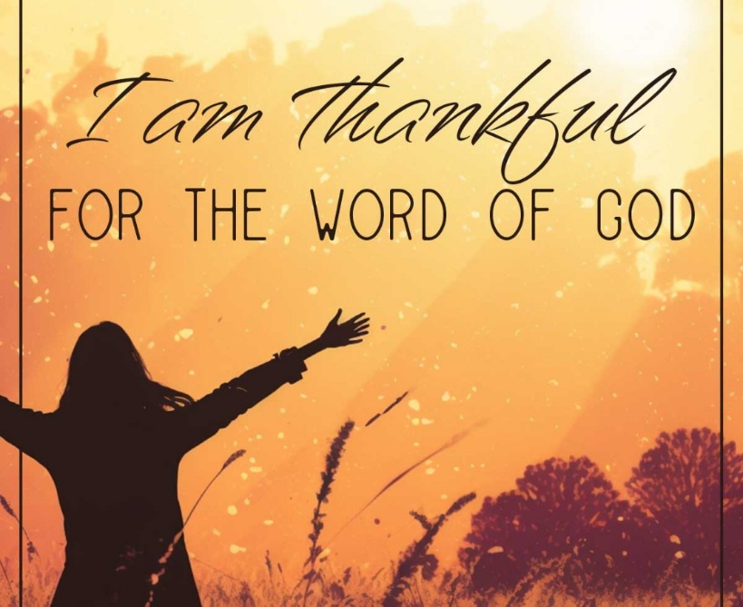

What’s on:

Sunday 22nd February
8.00am: Prayer Book Communion
9.30am: Morning Praise
Wednesday 25th February
9.30am: Holy Communion
10.30am: Warm Space Community Hub
7.30pm: Home Group at Dawn and Jess’.

Messages:

Lent Appeal

This Lent, can you join us in living out Christ’s commandment to love one another by responding to the challenge of taking something on for others? FSW is asking each church to take on one thing in support of families at a time when love, compassion, and practical help are needed more than ever.

Please see attached for more details.

FSW

The FSW collection this month is on Sunday 22nd, or to Kathy and Eric's house by the 25th.

FSW are requesting for the following items:


Caring for God’s Creation

Are you looking for simple ideas on how to take action for the climate and nature?

Our new Eco tips calendar for 2026 will keep you and your church inspired throughout the year. It has fresh ideas each month and will help to foster a lasting commitment to a greener lifestyle.

Use the link below to Access the Eco Calendar to find ideas about sustainability and living a greener lifestyle.

https://arocha.org.uk/easy-eco-tips-2026-calendar/

Guestling and Fairlight

Please see attached Guestling and Fairlight Parish Newsletter

Sarah – Parish Administrator

Whitegates Home Cooked Sunday Lunch

See attached flyer for details

Prayer:

If you would like a situation prayed about urgently, please contact the church Prayer Share. Contact Dawn 01424 255423 / 0750 7745 159

If you know anyone who would like to be added to the notices, please send me an email with their details. If you don’t want to receive this email each week, or would rather receive it in a different format, please let me know.
Please give information for notices to me by Thursday morning (contact details below).
Have a good week everyone,
Tony Demarco tonydemarcohastings@gmail.com

