**Westfield Church Notices Sunday 9th February**

**Valerie writes:**

Quiet Day

Time to be still; time to read, pray, think and enjoy nature. Time to paint, create and share food.

This describes our recent 'Quiet Day' at Broadlands Orchard, Brede, a new venue for us.

It was a special 'set apart' time in the beauty of the countryside with a garden of spring bulbs emerging.

A gift of a day; 'Peace, Love, Joy and Hope' were our themes.

An image of the anchor, God's secure and steadfast love and hope holding us tight in the turbulence of life, was clear in my mind as we drove home.

**A prayer by Eddie Askew**

Love is the anchor Lord,

the one sure thing

that holds us safe.

We have no cause to fear.

You are beside us,

Yes,

Ahead of us as well.

Love's landmark

and promising safe anchorage.

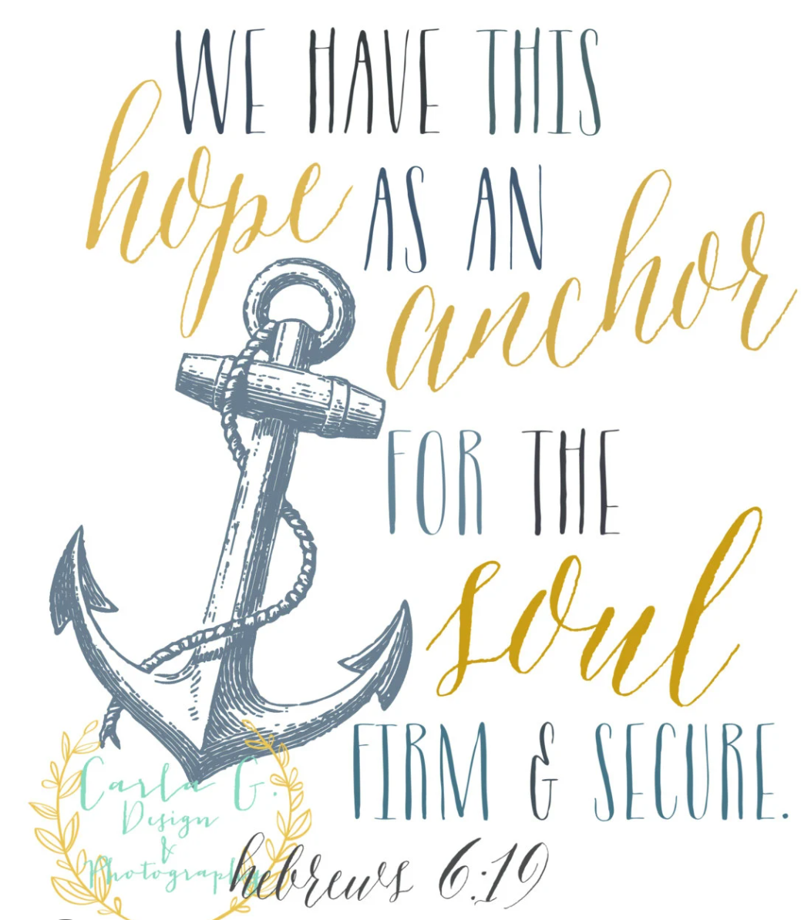

**What’s on:**

**Sunday February 9th**

8.00am: BCP Holy Communion

9.30am: Café Church

**Wednesday February 12th**

9.30am Prayer Book Communion

10.30am Warm Space Community Hub

**Ashburnham Filling Station 10th February 7pm**

The Filling Station is celebrating 10 years at Ashburnham and are inviting back some memorable speakers from that time. On the Monday 10th February the first speaker is James Nickols the South East Consultant for the Filling Station. The evening will include James’ talk, Prayer Ministry, music and refreshments. For more information see this link: [The Filling Station | Ashburnham](https://thefillingstation.org/station/ashburnham/)

**FSW Collection**

The FSW Collection at Westfield Church will next be on Sunday 23rd February.

**Messages from Sandi**

Did you know every time we gather to worship we have to consider how copyright law affects us? We're really grateful to Howard who for the last few years has been reporting online the songs we sing. Howard is also our Treasurer which takes a considerable amount of time and could do with passing on the song reporting to someone. Please would you be able to help by taking on reporting the songs? It takes about 10-15 minutes each week. You’ll need a computer and access to the internet. Sandi will show you what to do and is happy to answer questions as you go along. Please let her know if you can help.

A scam email is doing the rounds again appearing to be from Sandi (Fr Sandi Wickens) asking for you, as a valued staff member, to purchase some gifts cards for me. Please know that the real Sandi will never ask you to do this. To keep everyone safe online if in doubt about any email please check with Sandi first before replying. revsandiwickens@gmail.com

God bless,   
Sandi

**Prayer:**

If you would like a situation prayed about urgently, please contact the church Prayer Share. Contact Dawn 01424 255423 / 0750 7745 159

If you know anyone who would like to be added to the notices, please send me an email with their details. If you don’t want to receive this email each week, or would rather receive it in a different format, please let me know.  
Please give information for notices to me by Thursday morning (contact details below).

Have a good week everyone,

Tony Demarco

[tonydemarcohastings@gmail.com](mailto:tonydemarcohastings@gmail.com)