Westfield Church Notices Sunday 25th May

Valerie writes:

London City Mission

This month London City Mission is 190 years old. It was founded by David Nasmith in 1835 to assist people living in poverty. Graham Miller, LCM's Chief Executive says that poverty today is less obvious but still pervasive.

Graham continues, 'It's clear throughout the Bible that God has a heart for people on the margins. This is why the missionaries continue to go out, to meet people in their need and hopelessness and offer true hope through practical help and the Good News of Jesus'.

At Westfield Church we support Michael Prendergast as he works with churches in Southwark. Please have a browse on the Mission Noticeboard in the church porch and take one of Michael's newsletters.


​
Messages:

Fairlight Prayer Room

St Peter’s Church Fairlight will be transformed into a prayer space full of creative and interactive ways to pray for a few days during Thy Kingdom Come.

Where: St Peter’s Church, Corner of Waites Lane and the Broadway (next to the Village Hall), Fairlight, TN35 4DA

When: Thursday 29th May (Ascension Day) from 9am to Monday 2nd June 5pm. Closed between 8pm and 7am daily

Booking: Please use this link to book a time to pray so we can ensure everything is ready for you. https://pray.24-7prayer.com/signup/893d64 If you aren’t online please phone Sandi on 07395 106514 or email revsandiwickens@gmail and she will book you in.
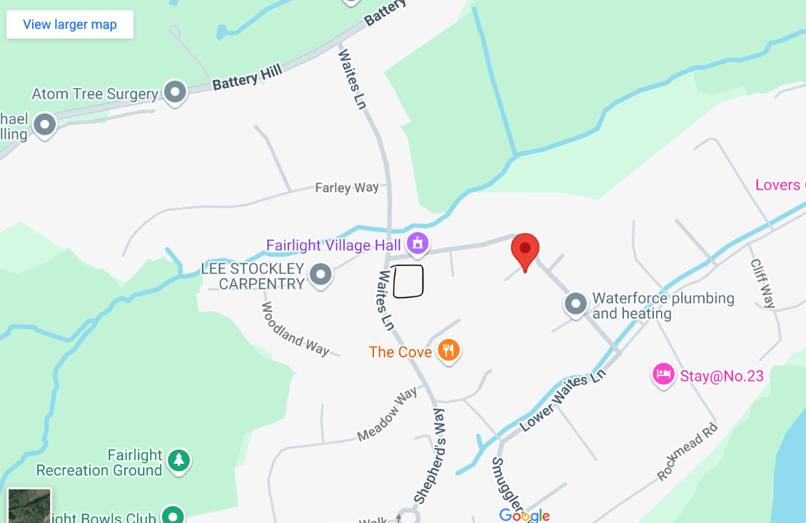
Access: There are four steps with a handrail at the front door. Level access is available to the back door from the pavement on Waites Lane. Please let Sandi know in advance if you require this.

What to expect: A small oasis of calm; a still place in a busy world for you to spend some time with God. There will be prayer stations with suggestions of ways you may wish to pray themed around the Lord’s Prayer. Come alone, bring a friend, or your homegroup. There will be help yourself refreshments in the kitchen and yes, there is a loo.

A Prayer Room at St Peter’s Church Fairlight will be set up as part of this years Thy Kingdom Come. Details are on the attachment and everyone is welcome.
God bless,
Sandi

FSW Collection

Sunday 25th May at Westfield Church or to Kathy and Eric’s house by morning of Wednesday 28th May

The FSW food bank is short of the following items:
Custard
Rice pudding
Shampoo
Toothpaste
Body wash
Savoury snacks
Squash

What’s on:

Sunday 25th May
8.00am: Holy Communion
9.30am: Morning Praise
Wednesday 28th May
9.30am Prayer Book Communion
10.30am Warm Space Community Hub
Thursday 29th May
7pm Ascension Day Holy Communion

Prayer:

If you would like a situation prayed about urgently, please contact the church Prayer Share. Contact Dawn 01424 255423 / 0750 7745 159

If you know anyone who would like to be added to the notices, please send me an email with their details. If you don’t want to receive this email each week, or would rather receive it in a different format, please let me know.
Please give information for notices to me by Thursday morning (contact details below).
Have a good week everyone,
Tony Demarco
tonydemarcohastings@gmail.com

